Adaptive Systems
2ID55

January 2011
Sanjuanelo Robles, E.J. (Kike) - 0XXXXXX
Dongen, M. van (Maarten) - 0642099
Bussel, M.W.H.A.C. van (Mike) - 0578052

Table of Contents
Introduction 3
Motivation 3
Structure 3
Adaptive elements 5
Conclusion and reflection 6

Introduction
This report is a description of the adaptive system made for the course Adaptive Systems (2ID55) taught at Eindhoven University of Technology. The adaptive system made, concerns a course about tennis. The structure and the adaptive elements in the designed course will be covered by later chapters. The course is made using the GRAPPLE Authoring Tool in the GRAPPLE adaptive learning environment.

Motivation
The choice to make an adaptive course about tennis was made after considering some other possibilities. Eventually three candidates were left to select from. These were the human body, golf and tennis. Tennis was preferred because of its larger appeal to the public and greater prior knowledge of the design team. As source for most of the information about tennis Wikipedia pages are used.

Structure
For the designed tennis course the following structure was used:
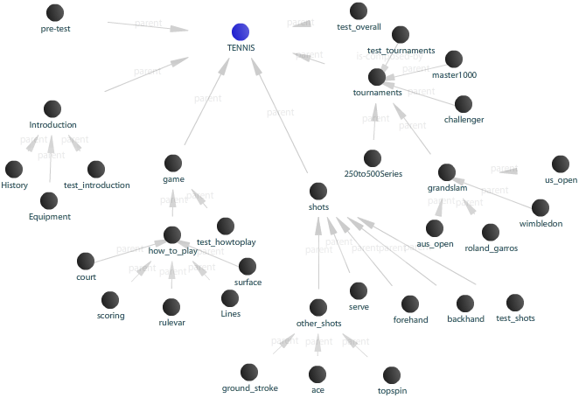
- Concept 000 Pretest
Multiple choice test to specify if the introduction is needed for the user.

- Concept 100 Introduction
This concept can be skipped if the pretest indicates enough knowledge about the very basics of tennis.

  - Concept 110 History
This concept explains the origin and history of tennis.

  - Concept 120 Equipment
This concept explains the equipment that is used during tennis.

  - Concept 199 Multiple choice test Introduction
Multiple choice test to check if the concepts in this part are understood.

- Concept 200 Tennis: the game
This concept explains how tennis the game is played.

  - Concept 210 Manner of play
This concept explains the rules of the game, plus some extra information that is needed to understand how the game is played.

    - Concept 211 Court
Explains the most important aspects of the tennis court.

    - Concept 212 Lines
This concept treats the different lines that are on the tennis court.

    - Concept 213 Surfaces
This is a concept about the surfaces on which the game is played.

    - Concept 214 Play of a single point
Explains how a typical tennis point is played.

    - Concept 215 Scoring
In this concept the scoring of a complete tennis match is explained, so scoring in a game, set and the whole match.

    - Concept 216 Rule variations
This concept explains the variations on the normal rules that can be used during a match or tournament.

  - Concept 299 Multiple choice test Tennis the game
Multiple choice test to check if the concepts in this part of the course are understood.

- Concept 300 Tennis shots
This concept explains which tennis shots there exists.

  - Concept 310 Forehand
Explains the forehand shot, and how it is used in practice.

  - Concept 320 Backhand
This concept treats the backhand shot.

  - Concept 330 Serve
The serve is explained by this concept.

  - Concept 340 Volley
In this concept the volley shot is explained, and when it is used during a rally.

  - Concept 350 Half volley
This concept explains the half volley.

  - Concept 360 Lob
The lob shot is explained by this concept, it also explains when the lob shot is used.

  - Concept 370 Smash
In this concept the smash shot is explained.

  - Concept 380 Drop shot
This concept explains the drop shot and when it is used during a match.

  - Concept 390 Other shots
This concept contains some sub concepts that explain some less familiar shots.

    - Concept 391 Groundstroke
In this concept it is explained what a groundstroke is.

    - Concept 392 Ace
This concept explains what an ace is.

    - Concept 393 Topspin
In this concept the topspin shot is explained and what effect it has on the way the ball moves.

    - Concept 394 Backspin
This concept explains what backspin is and how it can be used.

    - Concept 395 Flat
Explains what a flat shot is.

  - Concept 399 Multiple choice test Tennis shots
Multiple choice test to check if the concepts in this part are understood.

- Concept 400 Tournaments
This concept explains the different tournaments tennis has.

  - Concept 410 Grand Slam tournaments
This concept explains the general information about the Grand Slam tournaments.

  - Concept 411 Australian Open
In this concept information is given about the first Grand Slam of the year.

  - Concept 412 Roland Garros
This concept gives information about the only Grand Slam that is played on clay.

  - Concept 413 Wimbledon
In this concept the most prestigious Grand Slam of the tennis season is treated.

  - Concept 414 US Open
This concept explains the fourth and last Grand Slam of the season.

  - Concept 420 Masters 1000
In this concept the Masters 1000 tournament are treated.

  - Concept 430 250 and 500 Series
The 250 and 500 Series tournaments are explained in this concept.

  - Concept 440 Challenger Tour and Futures Tournaments
This concept is about tennis tournaments that are played on two lower levels.

  - Concept 499 Multiple choice test Tournaments
Multiple choice test to check if the concepts in this part are understood.

- Concept 500 Multiple choice test Overall
Multiple choice test to check if all concepts are understood. Maybe an adaption could be to redirect the user to concepts of which the questions were answered incorrectly.

Adaptive elements
Pre test determines…
Beginner advanced user view.

Conclusion and reflection
The quality of the adaptive elements in the course is not so high. Our group experienced a lot of bugs and in clarities in the GRAPPLE Authoring Tool. Also we found that is was extremely difficult to work with the tool using more than one machine. Probably a part of the errors was due to the fact synchronization was very difficult. This all causes that most of the effort went into trying to get the tool to work, trying to retrieve the work of group members and trying to resolve errors which popped up after seemingly trivial changes or adaptations to the models. Although a lot of effort is spent the result is somewhat disappointing, using only very limited and the most simple adaptation. It is clear to us, that the GAT still needs a lot of work before it can easily and intuitively be used for creating adaptive courses. We hoped for a better result, but this was not possible with this tool and our inability to resolve all the errors that the tool generated. Possible improvements to the assignment would, in our opinion, be organizing question hours after the regular lecture hours are finished, in which you can provide help and guidance when needed. And an improvement could also be to make the assignment somewhat smaller but individual. Eliminating all problems with synchronization.

